Brandon Chung, Davis Le, Daniel Nguyen, Matthew Tse

Professor Roldan

BUS4-92 Sec 01

December 16, 2020

GiftXPress - $10 Gift Card Store

Project Description/Statement:

Our program provides access to an easy and straightforward way of purchasing popular gift cards in the amount of $10. Our target audience includes young teens and adults who lack the appropriate time and/or money to purchase gifts, especially during holidays like Valentines and Christmas.

When the user starts the program, the user will be prompted with a GUI menu and will have a choice to select options ranging from displaying what the available items to purchase are, to the actual shopping process. When shopping, users are shown a greeting message and can pick one of the two available options for the $10 gift cards: Retail or Food, then choose one of the six popular gift cards associated with that option. Once the user is done choosing a gift card, the user will be given the option to add more gift cards if they desire or to confirm the purchase to be given a list of what they purchased along with their total price and a farewell message.

The popular $10 gift cards for each option are:

|  |  |
| --- | --- |
| **Retail** | **Food** |
| Visa | Taco Bell |
| Mastercard | Boiling Pot |
| Amazon | Happy Lemon |
| Apple | Panda Express |
| Microsoft | Starbucks |
| Walmart | Jamba Juice |
| Target | Subway |

Team Statement Form:

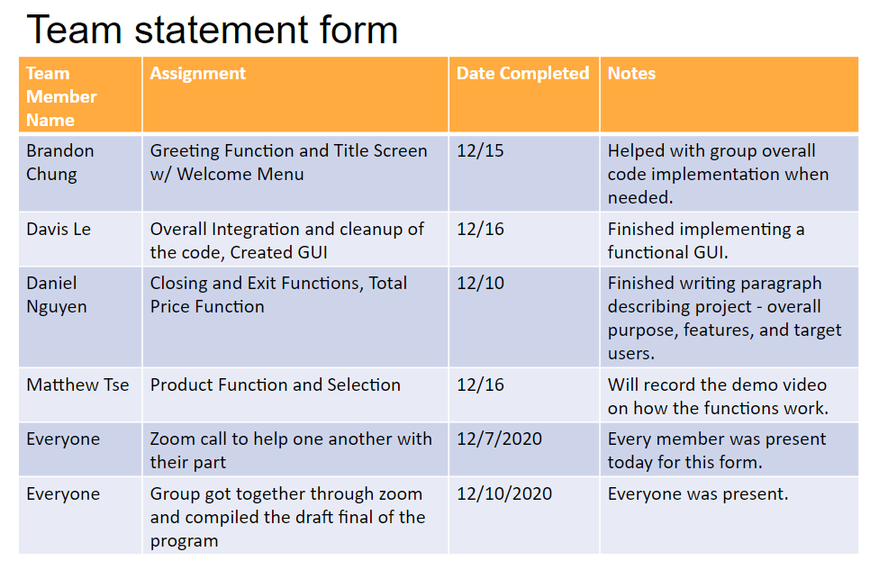

Additional notes:

|  |  |  |
| --- | --- | --- |
| Everyone | 11/16~30/2020 & 12/1~16/2020 | Updates were sent towards the group chat on progress of their part through text along with suggestions for the program. |
| Everyone | 12/16/2020 | Problems came about when compiling the video. Group mates texted each other/the professor to see what can be done to fix the problem. Eventually, the problem was fixed. |
| Everyone | 12/16/2020 | Everyone reviewed the project to make sure things were good. |
| Davis Le | 12/16/2020 | Finalized, cleaned up and compiled everything together. |

Signed Team Statement Form:

